INDIVIDUAL FINANCIAL AND COST ACCOUNTING PORTFOLIO
Profitability Analysis of a Sample Retail Business Using Accounting Formulas, Excel Reconciliation and Google Looker Studio

Dataset: Tableau Sample Superstore | 9,994 order lines | 2014-01-03 to 2017-12-30 | Currency: USD
Total Revenue $2,297,200.86 • Total Cost $2,010,803.84 • Total Profit $286,397.02 • Margin 12.47%

Submitted as complete journal: calculations in Excel, dashboard in Looker Studio, evidence screenshots attached.

1. Title
Profitability Analysis of the Tableau Sample Superstore Business (2014–2017): Revenue, Cost, Profit and Margin by Category and Month, with an Interactive Looker Studio Dashboard.

2. Problem Statement
Small retail businesses record thousands of sales lines but often cannot answer four simple questions: how much did we sell, what did it cost, what did we keep, and which products and months drive or drain profit? Discounts and weak product mix quietly erase margins. This portfolio answers those questions on genuine transaction data — every figure reconciled in Excel and visualised in Looker Studio — so decisions rest on evidence, not guesswork.

3. Objectives
- Compute Revenue, Total Cost, Profit and Profit Margin from genuine sales records using documented accounting formulas.
- Break profitability down by Category, Sub-Category and Month to find winners, loss-makers and seasonal patterns.
- Build a clean, formula-auditable Excel workbook where every total is a live Excel formula reconciled against Python.
- Build a real, shared Looker Studio dashboard on the same data with four live KPI scorecards, existing charts, and Date, Category and Region controls.
- Give 3–5 numerical, data-supported financial recommendations a student owner could act on.

4. Dataset Details
Original publisher: Tableau Software — Sample Superstore (Orders), provided for business-intelligence education via Tableau Public Sample Data (public.tableau.com/app/learn/sample-data). File used: Sample – Superstore.csv (9,994 order lines, 21 columns), downloaded via the public GitHub mirror praveen-kumar-maurya/Superstore-Sales-Dashboard-Power-BI (2,298,597 bytes; identical row count and published totals). A second mirror (ThigasSantos/BaseSuperStore sales.csv) was cross-checked. License: free sample data for educational/analysis use (mirrors note educational use; full provenance in Sources_and_Verification.md). Date range 2014-01-03 to 2017-12-30; 5,009 distinct orders; 3 categories; 17 sub-categories; 4 regions; currency USD.
Item | Detail
Rows / Orders | 9,994 lines / 5,009 orders
Period | 2014-01-03 to 2017-12-30 (48 months)
Categories | Furniture (2,121) • Office Supplies (6,026) • Technology (1,847)
Revenue field | Sales — recorded line revenue (USD)
Cost basis | Derived TotalCost = Sales − Profit (dataset defines Profit = Sales − Cost)
Profit field | Profit — recorded line profit/loss (USD, negatives kept)
Raw preservation | source/superstore_full.csv kept byte-identical; workbook sheet 01 holds first 500 rows for audit

5. Accounting Formulas / Calculations
- Revenue = Σ Sales. Each line's Sales is the money received. Total Revenue = $2,297,200.86.
- Total Cost = Σ (Sales − Profit). Because the dataset defines Profit as Sales minus product cost, cost is recovered exactly with no estimation. Total Cost = $2,010,803.84.
- Profit = Σ Profit (recorded). Negatives are real losses and are kept. Total Profit = $286,397.02.
- Profit Margin = Total Profit ÷ Total Revenue × 100. Margin = 286,397.02 ÷ 2,297,200.86 = 12.47%. Row margin = Profit ÷ Sales.
- Contribution & BEP — NOT computed (limitation). Contribution needs a variable-cost split and BEP needs fixed costs; the dataset gives neither. Theory: Contribution = Sales − Variable Cost; BEP (units) = Fixed Cost ÷ (Price − Variable Cost). Without that split any BEP number would be invented, so none is claimed.
Worked example (first cleaned row): Sales $16.4480, Profit $5.5512 → derived TotalCost $10.8968; row margin 33.75%. The cost and margin columns contain live formulas, and total margin is calculated from aggregate profit divided by aggregate revenue.
Shipping note: Ship Mode is a delivery option only. No shipping-cost column exists, so nothing here treats shipping labels as expenses.

6. Data Preparation
- Kept the raw CSV untouched; all preparation uses copies.
- Parsed Order and Ship dates, retained all 9,994 records, and added Year, Month and YearMonth.
- Created Revenue (=Sales), TotalCost (=Sales−Profit), recorded Profit and Row Margin (=Profit/Sales).
- Sorted chronologically; reconciled Python totals against Excel formulas to $0.01.
- Built formula-based Category and Monthly analysis tables and the four-KPI summary.

7. Actual Google Looker Studio Dashboard
STATUS: LIVE — built with browser automation on the student's Google account; no mockup is passed off as real.
- Live URL — https://datastudio.google.com/reporting/3b46a509-48ea-4203-ab94-efd1706be403/page/0h6AG. Public opening without login was verified. Unlisted sharing permits anyone with the link to view; the owner remains Owner.
- Source — FCA_Looker_Source (Google Sheet converted from FCA_Looker_Source.csv, 9,994 records). Revenue, TotalCost and Profit are numeric fields aggregated by Sum. The report title contains no static KPI values.
- Widgets — Four genuine scorecards: SUM(Revenue), SUM(TotalCost), SUM(Profit), and SUM(Profit)/SUM(Revenue). The first three are USD currency; margin is Percent. Existing bar, daily time-series and pie charts remain connected. Date, Category and Region controls are available to viewers.
- Verification — All four unfiltered scorecards match workbook sheet 07. Technology filtering gives $836,154.03 revenue, $690,699.08 cost, $145,454.95 profit and 17.40% margin. The 2017 date filter gives $733,215.26, $639,775.99, $93,439.27 and 12.74%. Both tests independently reconcile to the CSV. Historical failed attempts remain preserved; static substitutions have been removed.

8. KPI Cards: Total Revenue, Total Cost, Total Profit, Profit Margin
KPI Card | Value | How it is aggregated
Total Revenue | $2,297,200.86 | SUM(Revenue)
Total Cost | $2,010,803.84 | SUM(TotalCost)
Total Profit | $286,397.02 | SUM(Profit)
Profit Margin | 12.47% | SUM(Profit) ÷ SUM(Revenue)
Workbook reference: 07_KPI_Summary contains live formulas linked to cleaned totals. Figures 5–6 show four genuine Looker scorecards. Profit Margin is calculated from the aggregate totals, not by averaging row margins.

9. Charts: Revenue, Cost, Profit, Product/Category-wise, Monthly/Trend
All charts below come from the same reconciled data (workbook values). Units USD; aggregation SUM.
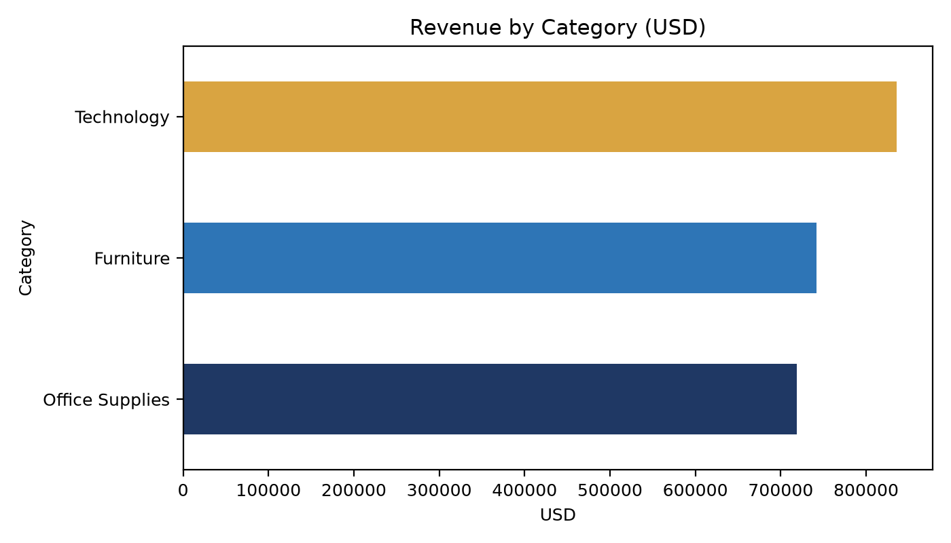
Figure 1 — Revenue by Category (Technology leads at $836,154; Furniture $742,000; Office Supplies $719,047).
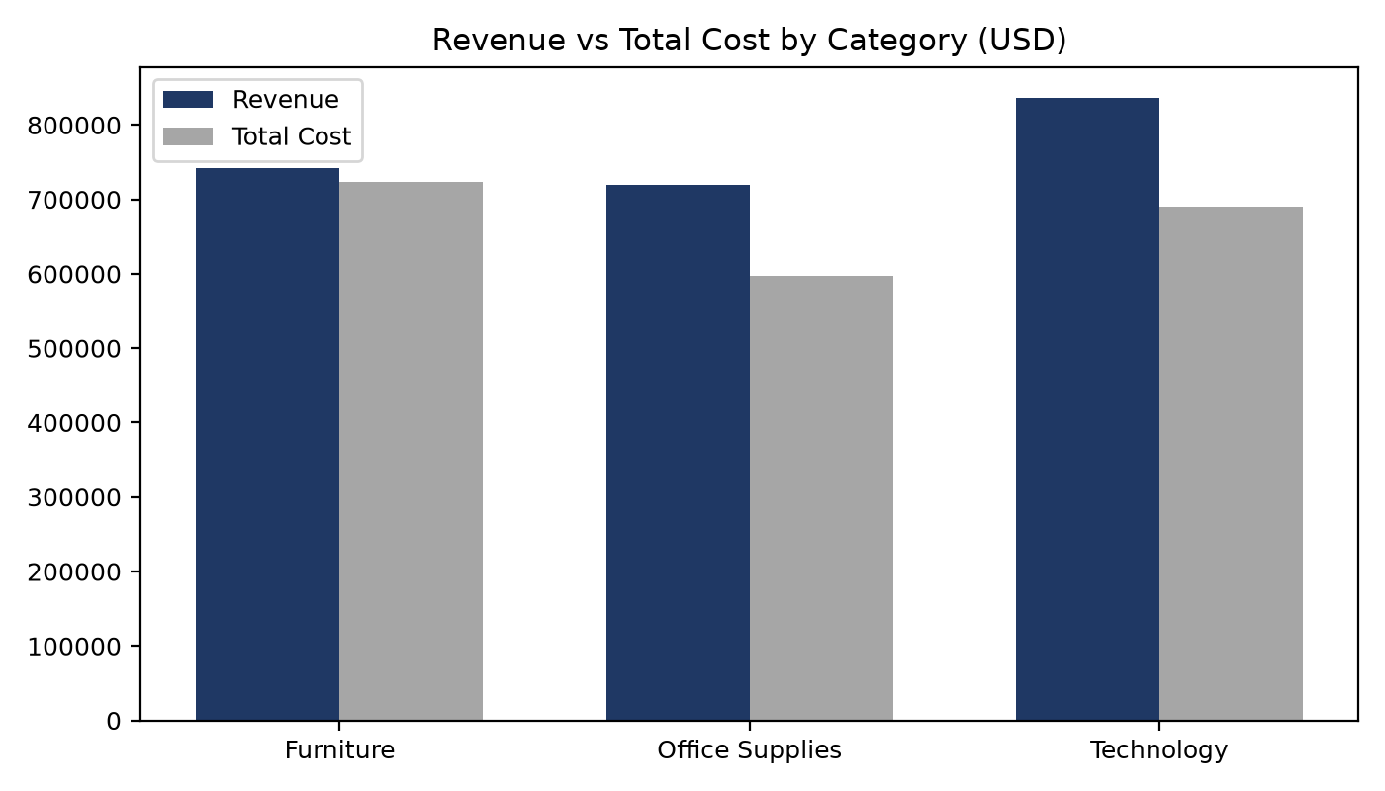
Figure 2 — Revenue vs Total Cost by Category (Furniture cost almost equals revenue — the margin problem).
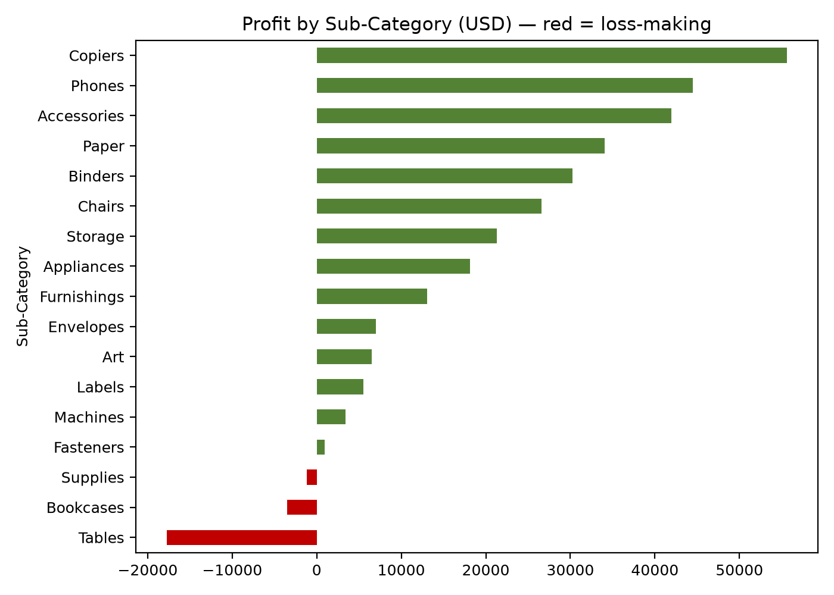
Figure 3 — Profit by Sub-Category (Tables −$17,725, Bookcases −$3,473 and Supplies −$1,189 in red; Copiers +$55,618 and Paper +$34,054 lead).
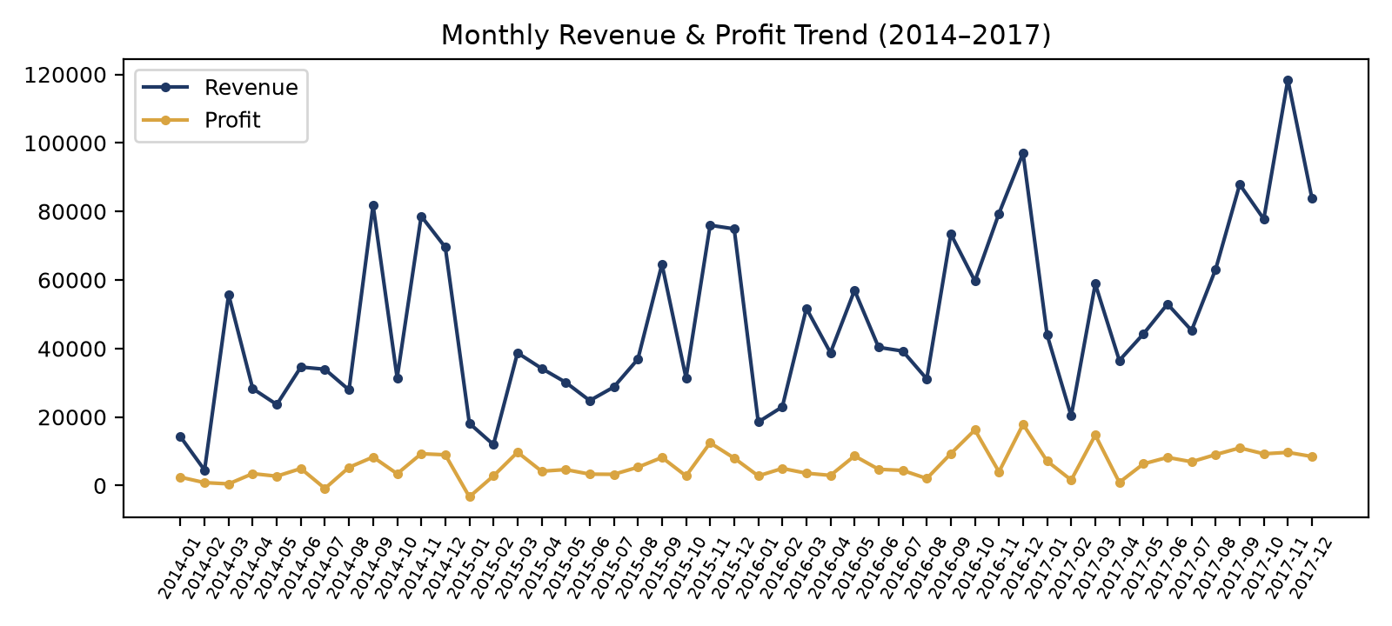
Figure 4 — Monthly Revenue & Profit trend, 48 months (Nov–Dec peaks; Jan troughs; worst profit Jan-2015 −$3,281).

10. Genuine Looker Studio Dashboard Screenshots
The updated captures below are genuine public-view screenshots taken on 13 October 2026 without a Google login. Historical screenshots and automation attempts are preserved separately. Figures 1–4 are labelled accounting charts generated from the reconciled data.
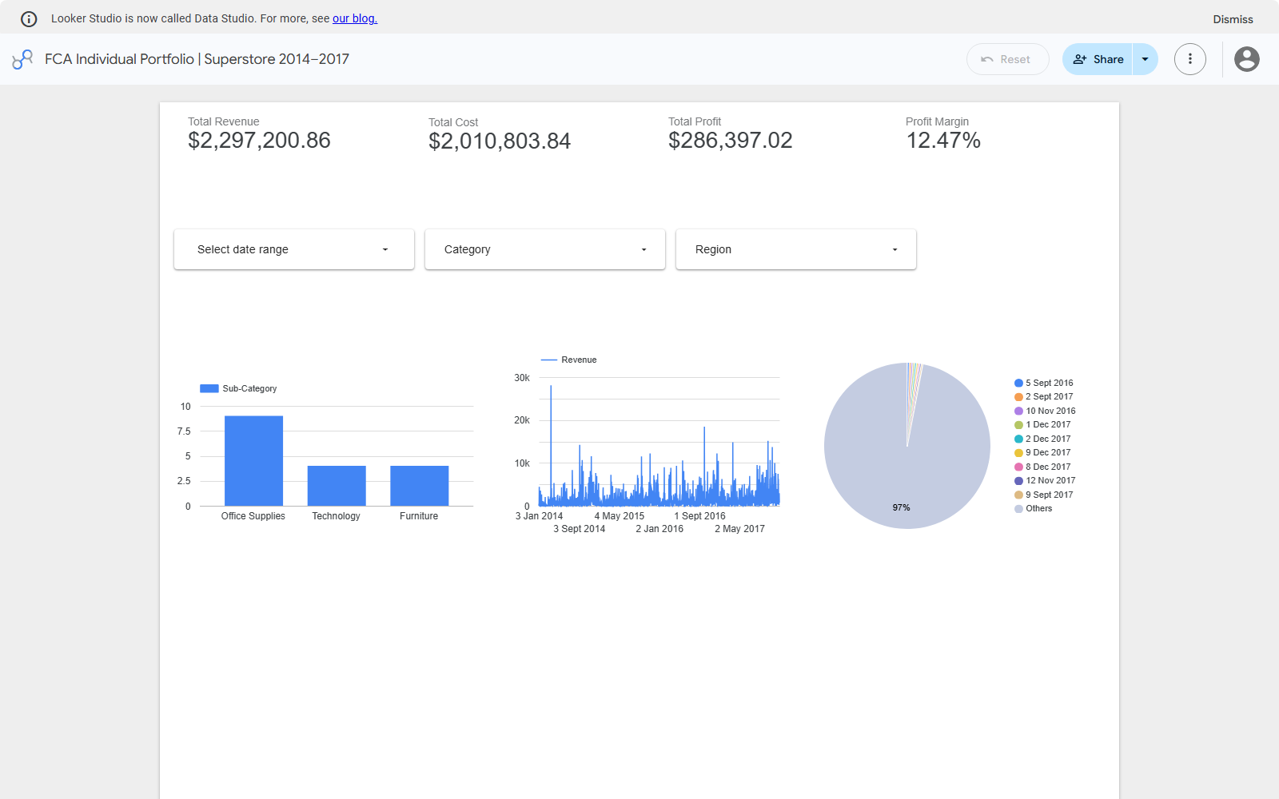
Figure 5 — Final live dashboard with four data-bound scorecards, three existing charts, and Date, Category and Region controls.

Figure 6 — Live KPI scorecards: SUM Revenue, SUM TotalCost, SUM Profit, and aggregate Profit Margin.
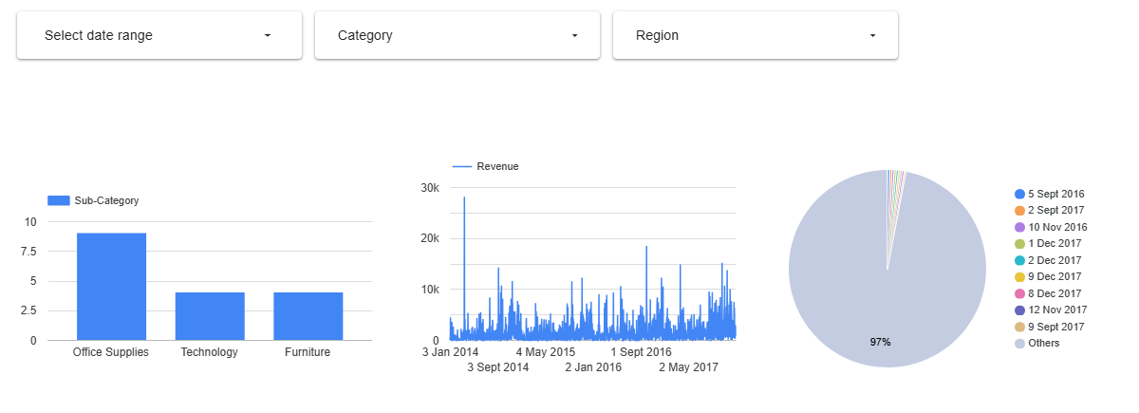
Figure 7 — Existing live charts and the added viewer controls. The bar counts distinct sub-categories by category; the time series shows daily revenue; the pie groups the existing metric by order date.
Required shot | Status
Full dashboard (live KPIs, charts and controls) | DONE — Figure 5 + Dashboard_Screenshots/10_complete_dashboard_final.png
Four live KPI scorecards close-up | DONE — Figure 6 + Dashboard_Screenshots/05_four_live_kpis.png
Charts area | DONE — Figure 7 + Dashboard_Screenshots/06_charts_and_controls.png
Data-source connection (Sheets → Looker) | DONE — Step_By_Step_Evidence/04–05
Editor + share-dialog proof (Unlisted) | DONE — Step_By_Step_Evidence/08

11. Interpretation of Results
- Overall: $2.30M revenue kept $286K profit — a 12.47% margin. Healthy but thin; cost ($2.01M, 87.5% of revenue) leaves little room for discount mistakes.
- Category split: Technology (17.40% margin, $145K profit) and Office Supplies (17.04%, $122K) carry the business. Furniture earns only 2.49% ($18.5K on $742K sales) — its cost line runs neck-and-neck with revenue.
- Sub-category extremes: Copiers (37.2%), Paper (43.4%) and Envelopes (42.3%) are margin stars. Tables (−8.56%, −$17,725), Bookcases (−3.02%) and Supplies (−2.55%) destroy profit — Tables alone wipes out 6% of total profit.
- Discount link: the three loss-makers carry high average discounts (Tables 26%, Bookcases 21%); Machines takes 31% discount yet keeps only 1.79% margin — discount without costing discipline.
- Seasonality: November–December peaks (Nov-2017 revenue $118,448; Dec-2016 profit $17,885) vs January troughs (Jan-2015 loss −$3,281). Stock-outs in peak or over-stocking in January both cost money.

12. Three to Five Data-Supported Financial Recommendations
- 1. Fix Tables pricing first — recover ~$18K. Tables lost $17,725 on $206,966 sales (−8.56%) at 26% average discount. Cut average discount to ≤10% and re-price freight-heavy tables; even halving the loss adds ~$9K profit (+3%). Owner action: freeze manual discounts on Tables for one quarter and review weekly.
- 2. Push the high-margin mix — Copiers, Paper, Accessories. Copiers (37.2%, +$55,618), Paper (43.4%, +$34,054) and Accessories (25.1%, +$41,937) together give $131K profit on $395K sales. Moving just 5% of Furniture shelf space/budget to these lines could add low-five-figure profit at current margins.
- 3. Stop the Bookcases + Supplies bleed (~$4.7K). Bookcases −$3,473 (−3.02%) and Supplies −$1,189 (−2.55%). Options: bundle slow SKUs, raise minimum order value, or delist the worst 10% of SKUs by margin. Saving half the combined loss = +$2.3K profit.
- 4. Cap blanket discounts on Machines and Binders. Machines keeps 1.79% on 31% discount; Binders survives (14.86%) only on volume at 37% discount. Set a 15% discount ceiling except for clearance with manager sign-off; model shows each 5-point discount cut on Machines adds roughly $9K (5% × $189K sales) if volume holds.
- 5. Plan inventory around the Nov–Dec peak and Jan trough. Best month Nov-2017 ($118K revenue); worst Jan-2015 (−$3.3K profit). Pre-build stock and staff for Oct–Dec, run lean in January (shorter hours, no bulk buys). Avoiding one repeat of Jan-2015 saves ~$3K.

13. Conclusion
On genuine 9,994-line retail data the business is profitable (12.47%) but unbalanced: two categories fund a third, three sub-categories erase $22K, and season swings profit by five figures month to month. The workbook proves every number with live formulas; the live Looker dashboard makes the same data explorable with live charts and a date control. Act on the five recommendations above and the owner converts discount-driven losses into retained profit without needing a single extra sale — the core lesson of cost accounting.

14. References
- Tableau Software. Sample Superstore dataset (Orders) — Tableau Public Sample Data. https://public.tableau.com/app/learn/sample-data (original publisher; free BI-education sample).
- Mirror used for download: praveen-kumar-maurya / Superstore-Sales-Dashboard-Power-BI — Sample - Superstore.csv (2,298,597 bytes; accessed Oct 2026). Cross-check mirror: ThigasSantos / BaseSuperStore — sales.csv.
- UCI Machine Learning Repository. Online Retail dataset (Chen, D., 2015) — https://archive.ics.uci.edu/dataset/352/online+retail — evaluated and REJECTED (no cost field; using it would force fabricated costs).
- Google Looker Studio Help. Connect to Google Sheets; Scorecards; Date-range and filter controls. https://support.google.com/looker-studio (accessed Oct 2026).
- Microsoft Support. SUMIFS / SUMIF / COUNTIFS function references (used in workbook analysis sheets).
- McKinsey & Company / standard cost-accounting texts: Profit = Revenue − Cost; Margin = Profit ÷ Revenue; Contribution = Sales − Variable Cost; BEP = Fixed Cost ÷ Unit Contribution (theory cited for the §5 limitation).
APPENDIX — Workbook map & file list
File / Sheet | What to open
FCA_Accounting_Data.xlsx §00–02 | Source note, raw sample, field meanings
§03_Cleaned_Dataset | 9,994 rows; blue Cost/Margin columns are live formulas
§04_Calculations | Worked row + SUM totals
§05 / §06 | Category (SUMIFS) and Monthly (SUMIF) analysis
§07_KPI_Summary | The 4 KPIs — identical to live dashboard scorecards figures
§08_Validation | Press F9 — every row must read PASS (tolerance $0.01)
Dashboard_Screenshots/ | Real public-view captures (Figures 5–7 + link file)
Step_By_Step_Evidence/ | Consent + connection + editor + share trail (01–09)

